TASK 1

You need to pick any **large-cap** company and do a thorough **fundamental and technical analysis of that company**.

**At least 3** **Technical indicators** should be analyzed for the technical analysis part.

**At least 5** **Ratios and parameters (fundamental)** evaluations are expected.

Will you be buying or shorting the stock at this point of time?

Explain with the help of the analysis done above.

OPTIONAL - Valuation of the company

Company - INFOSYS

(”The future is digital, and Infosys is the leader in digital”)

# Fundamental Analysis

# Letter to shareholder

The financial year 2022 was an outstanding year for the Company, our clients, our employees, and our shareholders. We have had the fastest growth, close to 20%, in 11 years. We are gaining market share. Our digital work is now almost 60% of everything we do, growing at about 40%. Our digital capabilities are comprehensive and of immense value for our clients. Our Cobalt™ cloud capabilities are market-leading across infrastructure-as-a-service, platform-as-a-service, and software-as-a-service. Our Equinox platform is attracting more digital retail businesses and delivering leading omnichannel experiences for them. We continue to build our data, analytics, AI, cybersecurity, and IoT expertise. Our automation capabilities are industry-leading and poised to support our clients as they look at ongoing efficiency and productivity improvements.

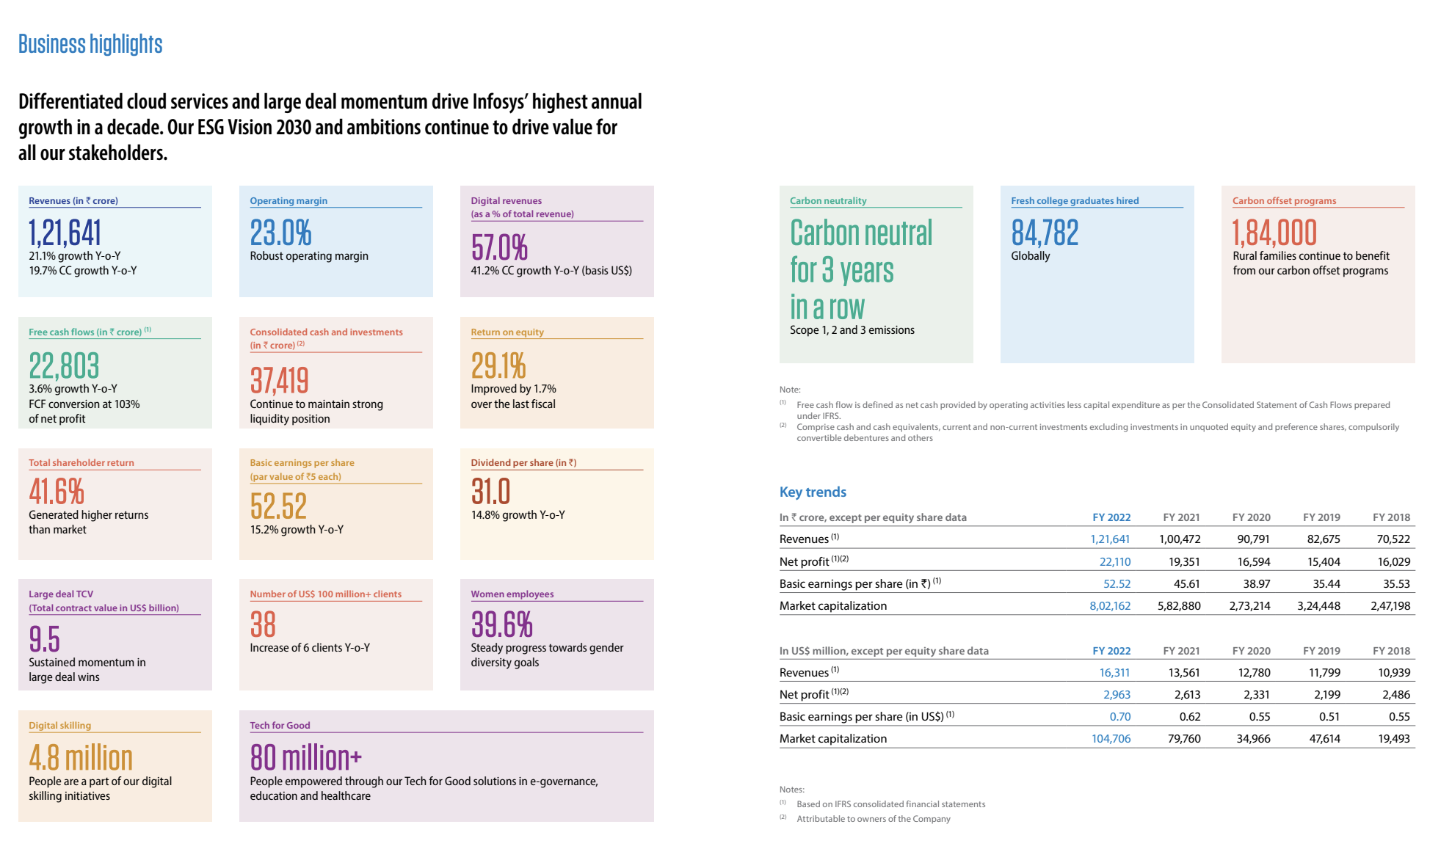

We had a successful year in delivering an operating margin of 23%. We returned cash to our shareholders as dividends of US$ 1.7 billion and share buyback of US$ 1.5 billion, for a total of US$ 3.2 billion for the year. Our earnings per share increased by 15% in Rupee terms this past year.

# Some of the critical statements from Management‘s discussion and analysis:-

Infosys is a leading provider of consulting, technology, outsourcing and next-generation digital services, enabling clients in **54 countries** to create and execute strategies for their digital transformation.

We have invested in building proprietary intellectual property  
 in software platforms and products, such as Infosys CobaltTM, Finacle®, McCamish, Panaya, Meridian, Helix, Infosys Equinox, Wingspan, the Edge suite of products, Stater, Infosys Applied AI, CyberNext, Infosys Cortex and Infosys Live Enterprise Application Suite, which either amplify our own services or provide differentiated solutions for our client’s business processes.

invest in Infosys CobaltTM – a set of services, solutions and platforms for enterprises to accelerate their cloud journey. It offers **35,000 cloud assets and over 300 industry cloud solution blueprints.**

**Our Competition**

We typically compete with other large, global technology service providers in response to requests for proposals. We potentially see emerging competition to our services from niche software-as-a-service companies, cloud platform companies and insourcing of technology services by the technology departments of our clients.

We have one class of shares – equity shares with a par value `of 5 each. During the year, the movement in share capital was primarily  
on account of a buyback of 5,58,07,337 shares resulting in a cash outflow of ` 9,200 crores.

There was no addition to goodwill and other intangible assets in the current year.

Our investments comprise mutual funds, fixed maturity plan securities, tax-free bonds, non-convertible debentures, certificates of deposit, commercial paper and government securities.

Days Sales Outstanding has reduced to 67 days in the current year from 71 days in the previous year due to the Management’s strong focus on ensuring timely collection from clients

# Financial Statements

(in ₹ crore, except equity share and per equity share data )

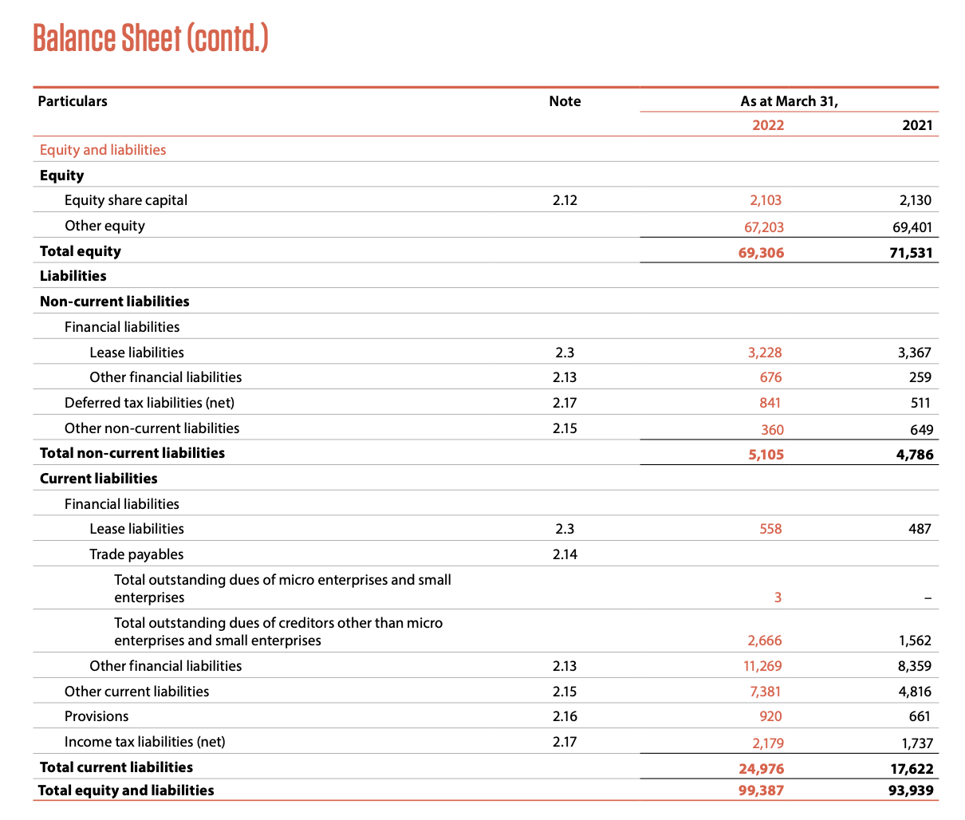

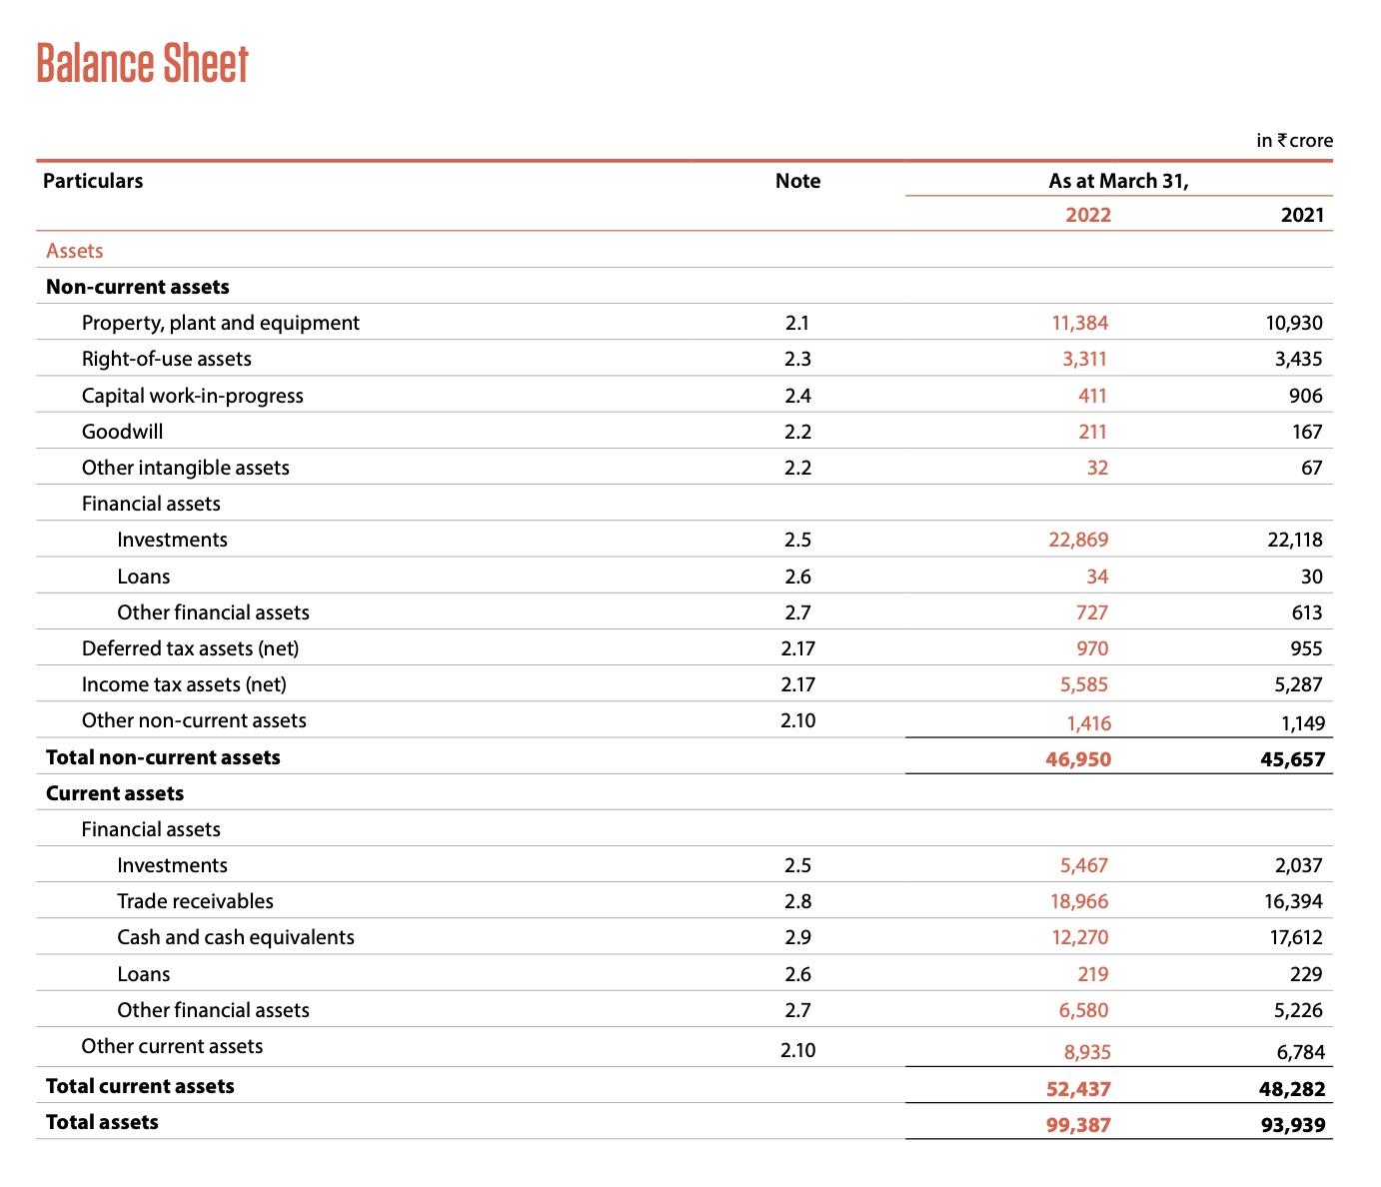

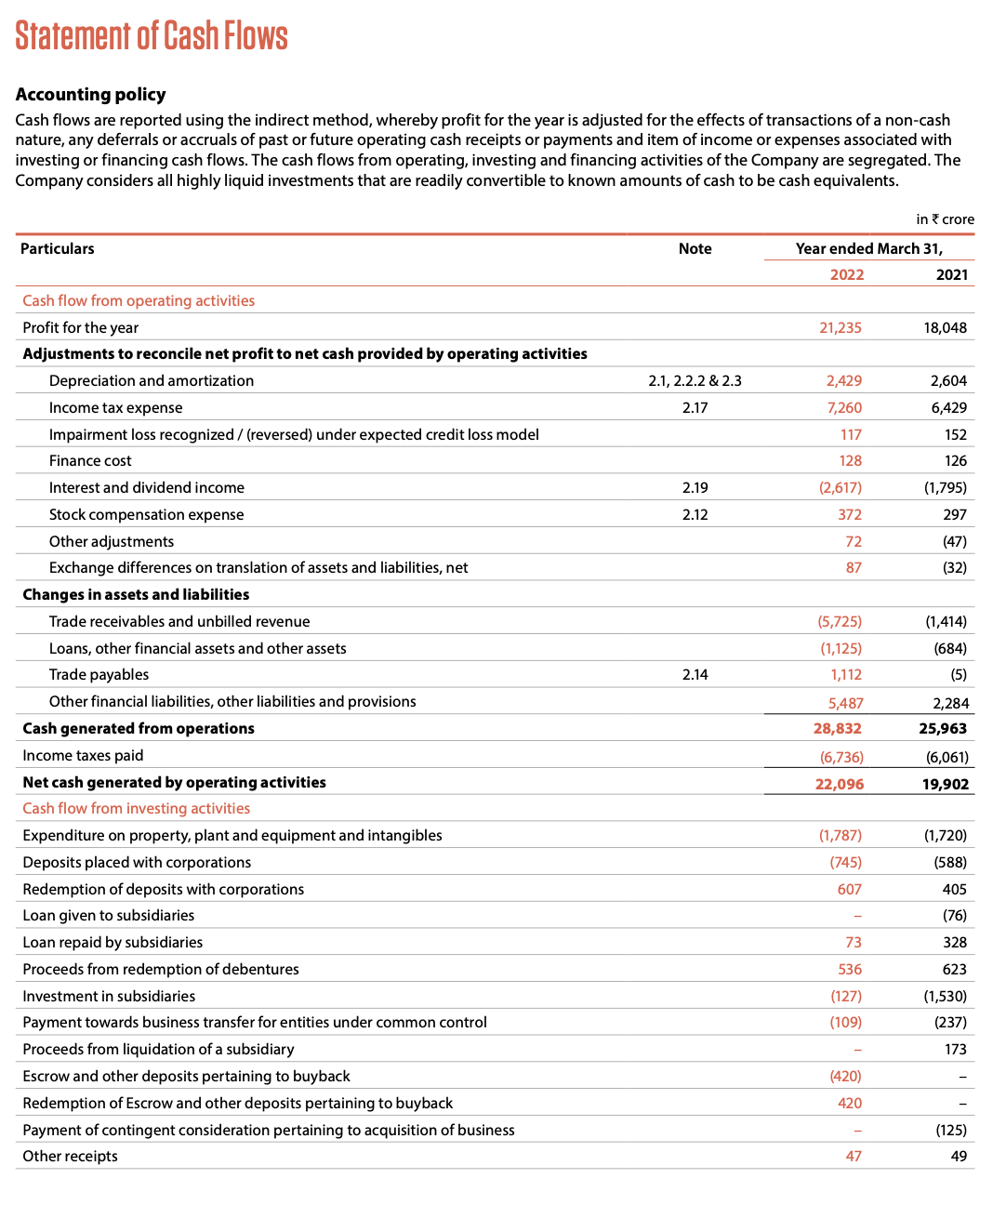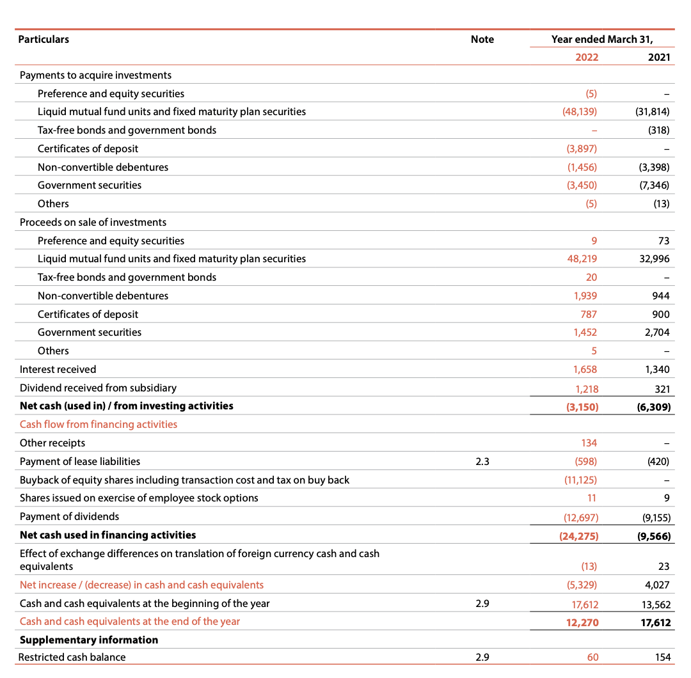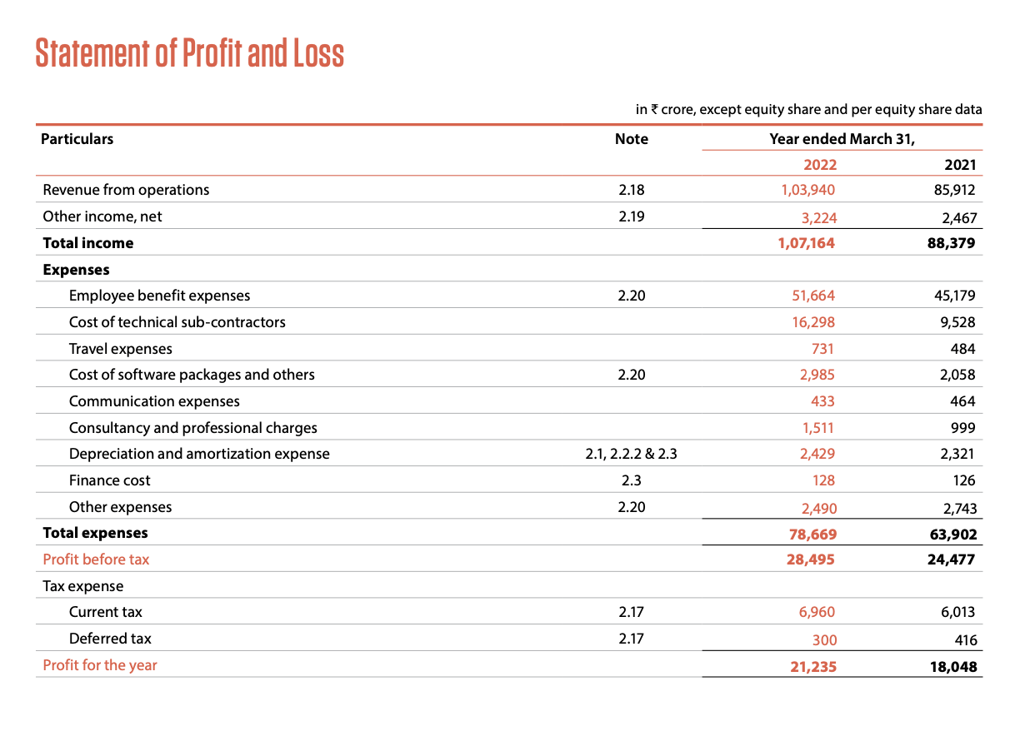

## Profit and Loss Statements:

Total revenue = 107164

Revenue from operations = 103940

Significant expenses = 51664 (Employee benefit expenses - even more than last year being covid)

Total expenses = 78669

PAT = 21235

## Balance sheet:

Trade receivables = 18966

Total assets = 99387

Current liabilities= 24967

Total Equity = 69306

Total liabilities = 24976

Total non-current Liabilities/debt = 5105

## Cash flow

Cash and cash equivalents = 12270

Investing = 3150

Financial = 24275

Operating = 22096

investing + financial = 27425 > operating

# Ratios

EBITDA = total income - total expenses = 107164 - 78669 = 28495

PAT margin = PAT/total income = 21235/107164 = 0.198154 = 19.81%

Operating profit margin = 28495/ 103940 = 0.274185 = 27.41 of profit per 100 sales

ROE = PAT /shareholder’s equity = 21235 / 69306 = 0.306394 = 30.63% return on equity

Debt to Equity = 5105/69306 = 0.073658 = 7.36 debt on 100 equity

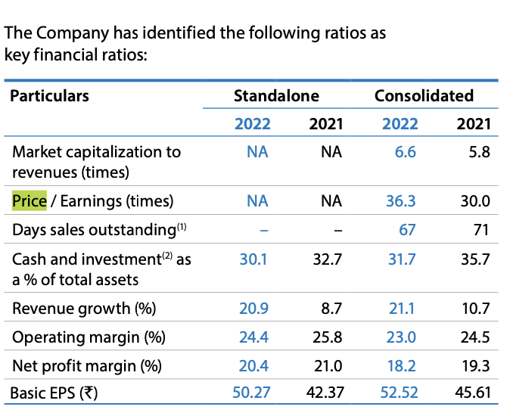

“Infosys was listed in NASDAQ till 11th Dec 2012.”

Share price = 1922.23

No. of Outstanding share = 404

Book Value = Equity/No. of outstanding shares =

69306/404 = 171.54 (this should be the ideal price per share, and we can see that the current price is even more the 10 times the book value)

#### 

#### Company receivables and debt are high, but the stocks are doing quite well as risk is relatively low on equity holders compared to the return on that equity.

# Technical analysis:

Timeframe: **1 week**

**MACD** indicator: According to MACD we can predict that prices will go up.

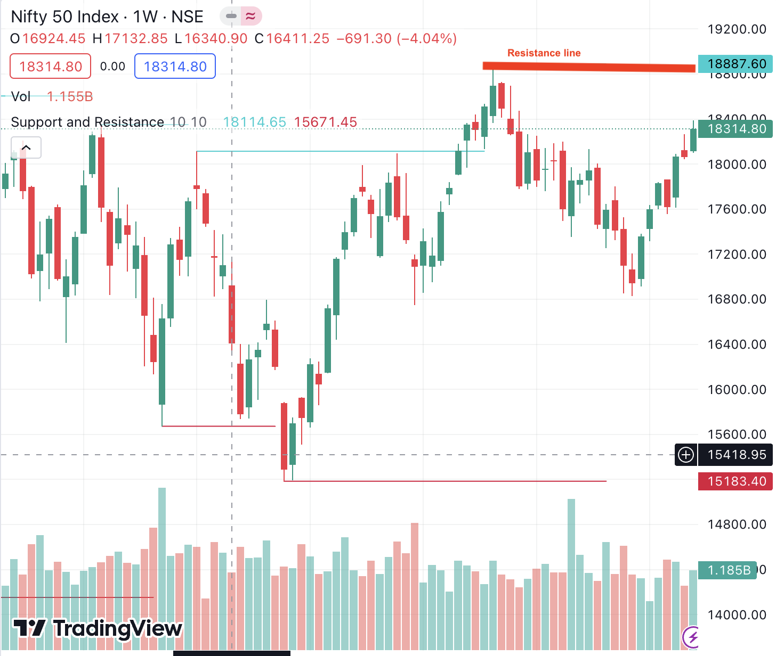

**Resistance and support line:**

In this case, we use the resistance line, and we see that the resistance line is above the current price, and this agrees with the prediction of MACD.

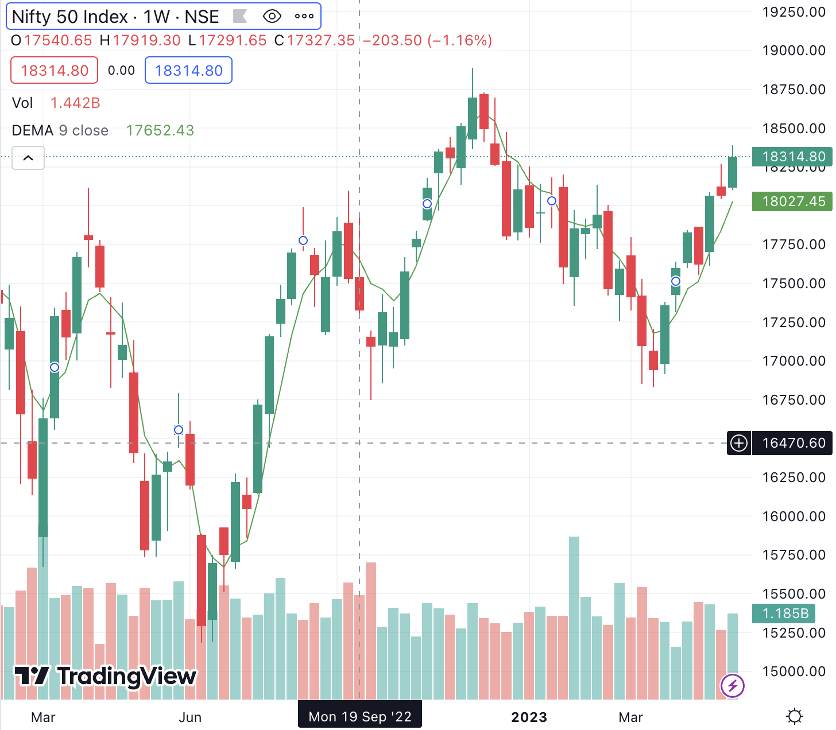

**Double EMA:**

Upwards trends also suggest a bullish market.

**CONCLUSION:**

From the past history, fundamental analysis of Infosys of March2023 and current market technical analysis suggests prediction to a bullish market for its stocks.